Mean RMSE vs. Frequency spacing (Hz)

Two anti-resonances (and one resonance)

F = 500; Fbw = 100;
Z1 = 1000; Z2vect = 2000:-10:1000;
Zbw = [100 100]';
dur = .5; % in s
pNoiseVar = 10;
snr_dB = 25;
cepOrder = 15;
fs = 16e3;
plot_flag = 0;
algFlag = [0 1]; % Select 1 to run, 0 not to; [EKF EKS]
x0 = [F; Z]+0;

10 simulations as first pass

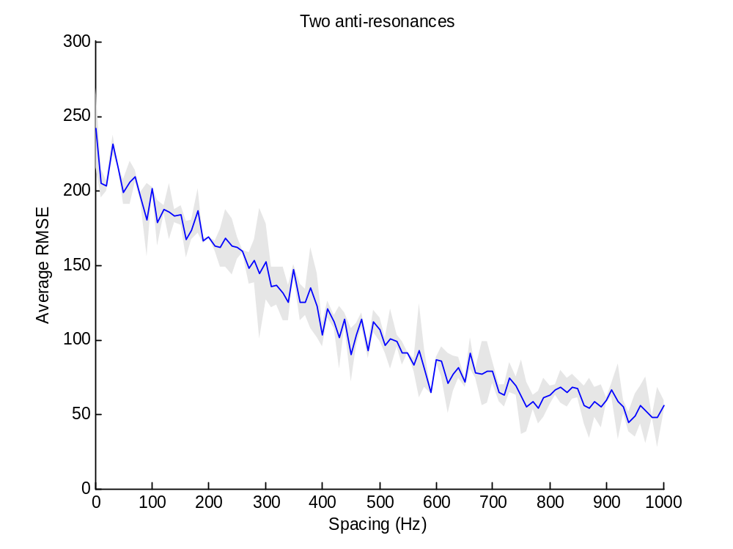
Mean RMSE vs. Frequency spacing (Hz)

Two resonances

%% parameters for pole/pole
F1 = 1000; F2vect = 2000:-10:1000;
Fbw = [100 100]';
Z = []; Zbw = [];
dur = .5; % in s
pNoiseVar = 10;
snr_dB = 25;
cepOrder = 15;
fs = 16e3;
plot_flag = 0;
algFlag = [0 1]; % Select 1 to run, 0 not to; [EKF EKS]
x0 = [F; Z]+0;

10 simulations as first pass

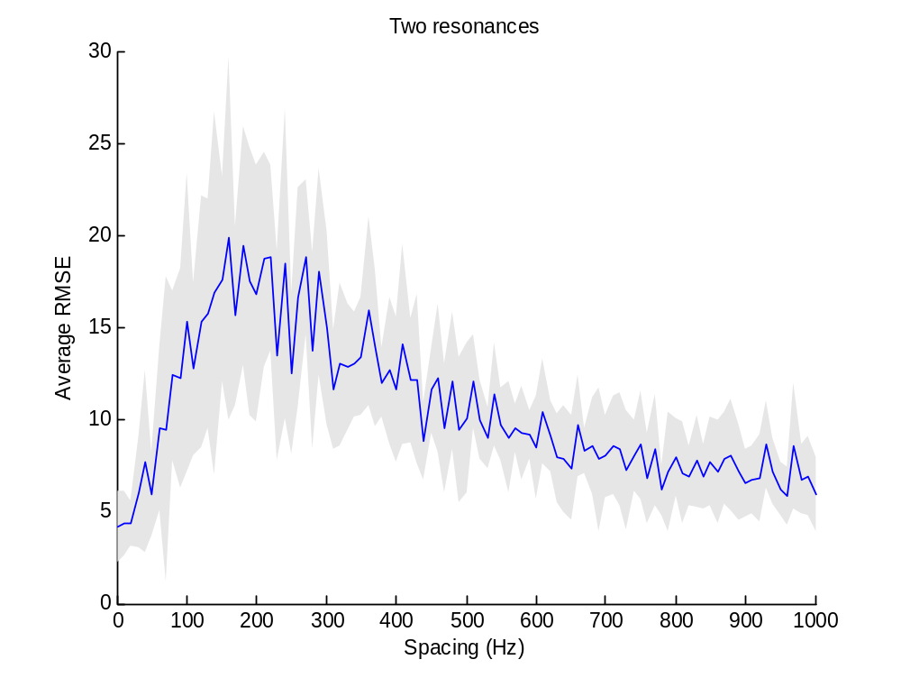
Mean RMSE vs. Frequency spacing (Hz)

One resonance, one anti-resonance

%% parameters for pole/zero
F = 1000;
Fbw = [100]';
Zvect = 2000:-10:1000; Zbw = [50];
dur = .5; % in s
pNoiseVar = 10;
snr_dB = 25;
cepOrder = 15;
fs = 16e3;
plot_flag = 0;
algFlag = [0 1]; % Select 1 to run, 0 not to; [EKF EKS]
x0 = [F; Z]+0;

10 simulations as first pass

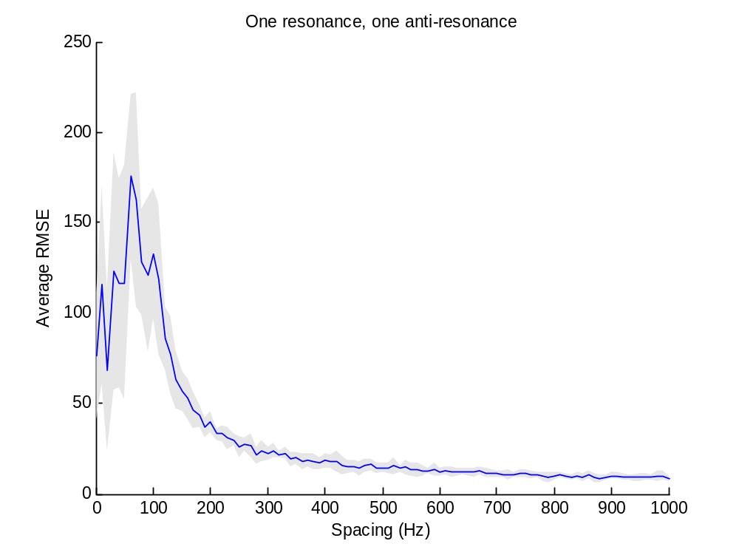
Mean RMSE vs. # Cepstral coefficients

Four resonances, three anti-resonances

F = [500 1500 2500 3500]';
Fbw = [100 100 100 100]';
Z = [700 1300 2700]'; Zbw = [50 50 50]';
dur = .5; % in s
pNoiseVar = 10;
snr_dB = 25;
cepOrder_vect = 25:-1:5;
fs = 16e3;
plot_flag = 0;
algFlag = [0 1]; % Select 1 to run, 0 not to; [EKF EKS]
x0 = [F; Z]+100;

10 simulations as first pass

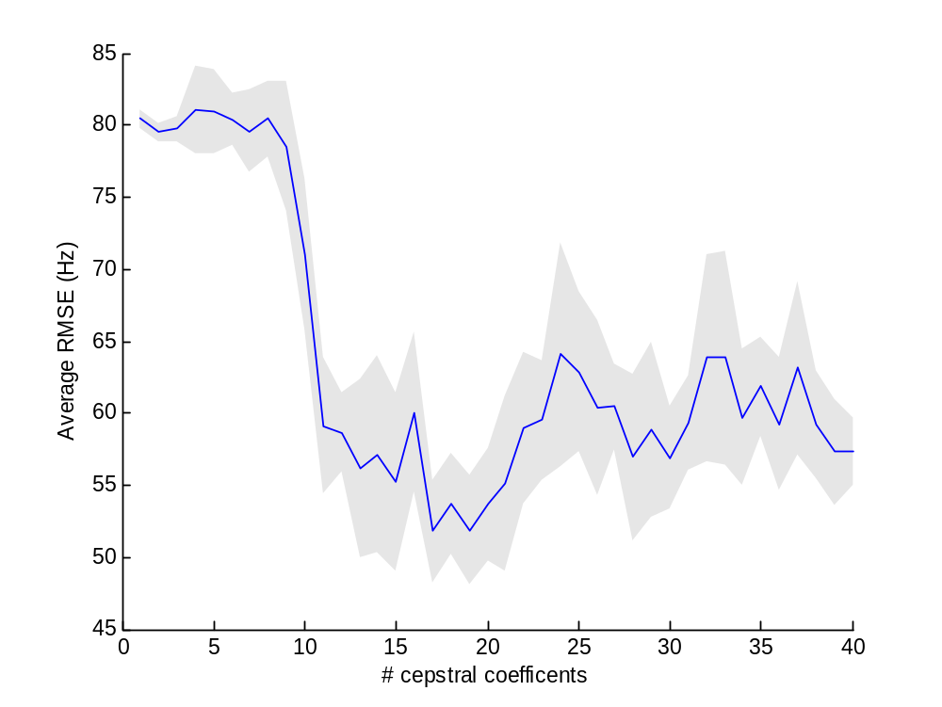

NB: for all plots above:
wType = 'hamming'; % window type
wLengthMS = 20; % Length of window (in milliseconds)
wOverlap = 0.5; % Factor of overlap of window
lpcOrder = length(F)*2; % Number of LPC coefficients
zOrder = length(Z)*2; % Number of MA coefficients
peCoeff = 0; % Pre-emphasis factor

Overlap-Add Analysis/Synthesis

Sinewave modulation (3 pole pairs, 1 zero pair)

%%%%%%%%%%%%%%%%%%%%%%%%%%%%%%%%%%%%%%%%%%%%%%%%
% SYNTHESIS
%%%%%%%%%%%%%%%%%%%%%%%%%%%%%%%%%%%%%%%%%%%%%%%%
dur = .5; % in s
snr_dB = 25;
cepOrder = 25;
fs = 16e3;
plot_flag = 1;
algFlag = [0 1]; % Select 1 to run, 0 not to; [EKF EKS]
wType = 'hanning'; % window type
wLengthMS = 20; % Length of window (in milliseconds)
wOverlap = 0.5; % Factor of overlap of window

%% sinewave modulated trajectory
Fbeg = [500 1500 2500]';
Fbw = [100 100 100]';
Fpert = 75*repmat(cos(2*pi*4*[1:numFrames]/numFrames*dur)', 1, size(Fbeg, 1));
Fcontour = interp1( [1 numFrames]', [Fbeg Fbeg]', 1:numFrames );
Fcontour = Fcontour + Fpert;

Zbeg = [800]';
Zbw = [100]';
Zpert = 100*repmat(cos(2*pi*4*[1:numFrames]/numFrames*dur)', 1, size(Zbeg, 1));
Zcontour = interp1( [1 numFrames]', [Zbeg Zbeg]', 1:numFrames );
Zcontour = Zcontour' + Zpert;

%% initial state
x0 = [Fcontour(1, :)'; Zcontour(1, :)']+100;

%%%%%%%%%%%%%%%%%%%%%%%%%%%%%%%%%%%%%%%%%%%%%%%%
% ANALYSIS
%%%%%%%%%%%%%%%%%%%%%%%%%%%%%%%%%%%%%%%%%%%%%%%%
wType = 'hamming'; % window type
wLengthMS = 20; % Length of window (in milliseconds)
wOverlap = 0.5; % Factor of overlap of window
lpcOrder = size(Fcontour, 2)*2; % Number of LPC coefficients
zOrder = size(Zcontour, 2)*2; % Number of MA coefficients
peCoeff = 0; % Pre-emphasis factor

process noise variance of each track is calculated as the variance of the respective state-to-state sequence

20 simulations as first pass
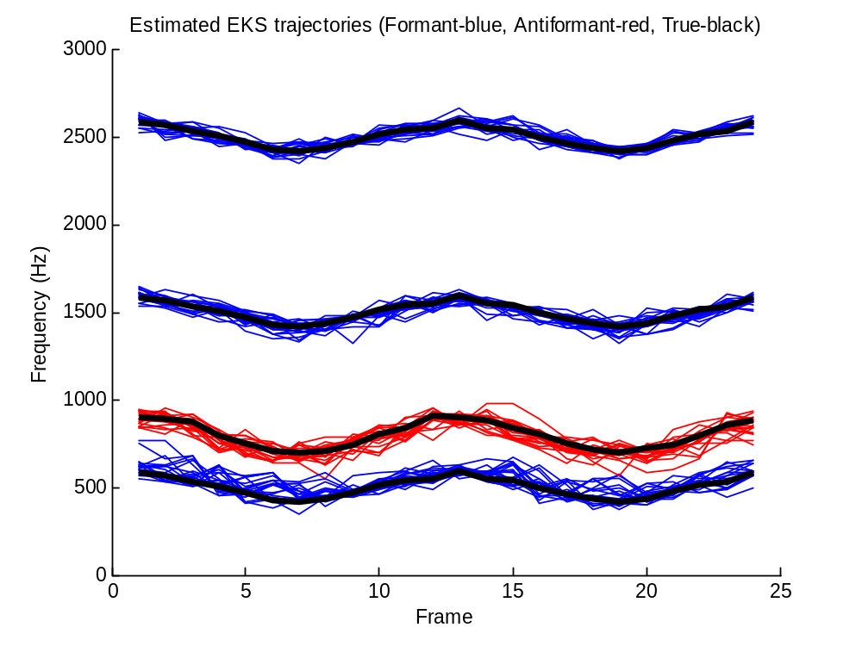
Average rmse for the 20 trials: 39 Hz

Another view with standard error around mean estimate:
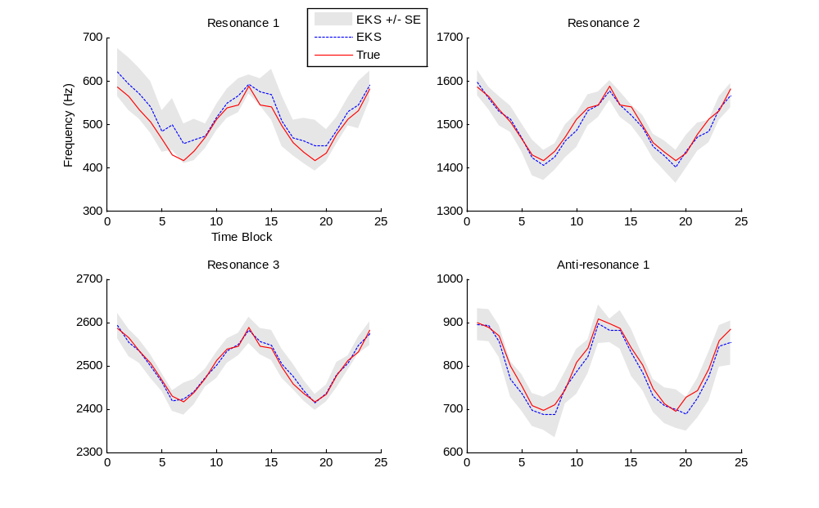
Overlap-Add Analysis/Synthesis

Piecewise linear trajectory (3 pole pairs, 1 zero pair)

%%%%%%%%%%%%%%%%%%%%%%%%%%%%%%%%%%%%%%%%%%%%%%%%
% SYNTHESIS
%%%%%%%%%%%%%%%%%%%%%%%%%%%%%%%%%%%%%%%%%%%%%%%%
dur = .5; % in s
snr_dB = 25;
cepOrder = 25;
fs = 16e3;
plot_flag = 1;
algFlag = [0 1]; % Select 1 to run, 0 not to; [EKF EKS]
wType = 'hanning'; % window type
wLengthMS = 20; % Length of window (in milliseconds)
wOverlap = 0.5; % Factor of overlap of window

%% Piecewise linear trajectory
Fbeg = [500 1500 2500]';
Fend = [1000 1100 3000]';
Fcontour = interp1( [1 numFrames]', [Fbeg, Fend]', 1:numFrames ) + repmat(10*randn(size(Fcontour,1),1), 1, size(Fcontour,2));
Fbw = [100 100 100]';

Zbeg = [4000]';
Zend = [4000]';
Zcontour = interp1( [1 numFrames]', [Zbeg, Zend]', 1:numFrames )' + repmat(10*randn(size(Zcontour,1),1), 1, size(Zcontour,2)); % if one anti-formant, need to take transpose here
Zbw = [100]';

%% initial state
x0 = [Fcontour(1, :)'; Zcontour(1, :)']+100;

%%%%%%%%%%%%%%%%%%%%%%%%%%%%%%%%%%%%%%%%%%%%%%%%
% ANALYSIS
%%%%%%%%%%%%%%%%%%%%%%%%%%%%%%%%%%%%%%%%%%%%%%%%
wType = 'hamming'; % window type
wLengthMS = 20; % Length of window (in milliseconds)
wOverlap = 0.5; % Factor of overlap of window
lpcOrder = size(Fcontour, 2)*2; % Number of LPC coefficients
zOrder = size(Zcontour, 2)*2; % Number of MA coefficients
peCoeff = 0; % Pre-emphasis factor

process noise variance of each track is calculated as the variance of the respective state-to-state sequence

20 simulations as first pass
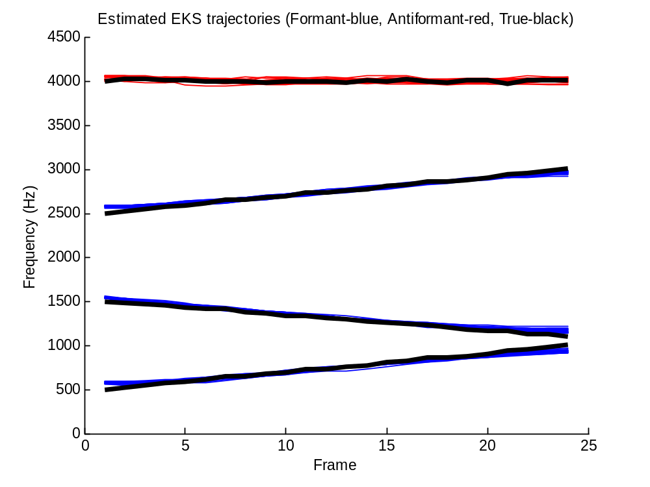
Mean rmse over 20 trials = 29 Hz
Another view with standard error around mean estimate:
